Sales Tax
Ohio

Login to the OBG for your client. Usernames and passwords can be found on the “Client Info USE” file on either the client’s tab or the Shared OBG password tab.

https://ohid.ohio.gov/wps/portal/gov/ohid/login

Scroll down until you find the payment you are trying to make (UST-1 for Sales Tax, UUT-1 for Use Tax) and click the “Play” icon.

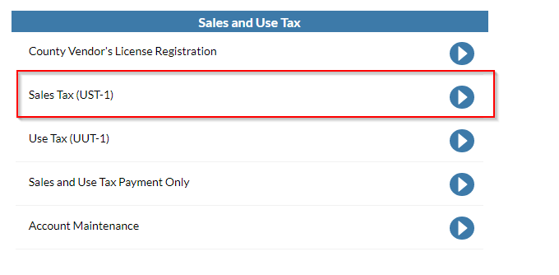

Read through any acknowledgements, select the tickmarks, and click next.

Follow the prompts to select the proper filing year, period, & type.

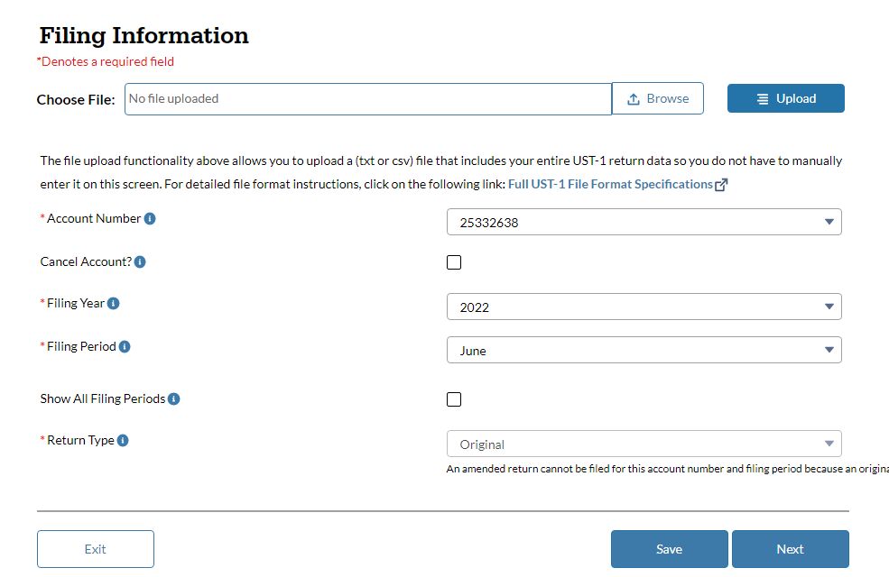

Enter the taxable sales (work with Amy to understand how to identify for each client) and multiply by the county’s tax rate (should default to prior month). If the client moves counties, we will need to include both and prorate.

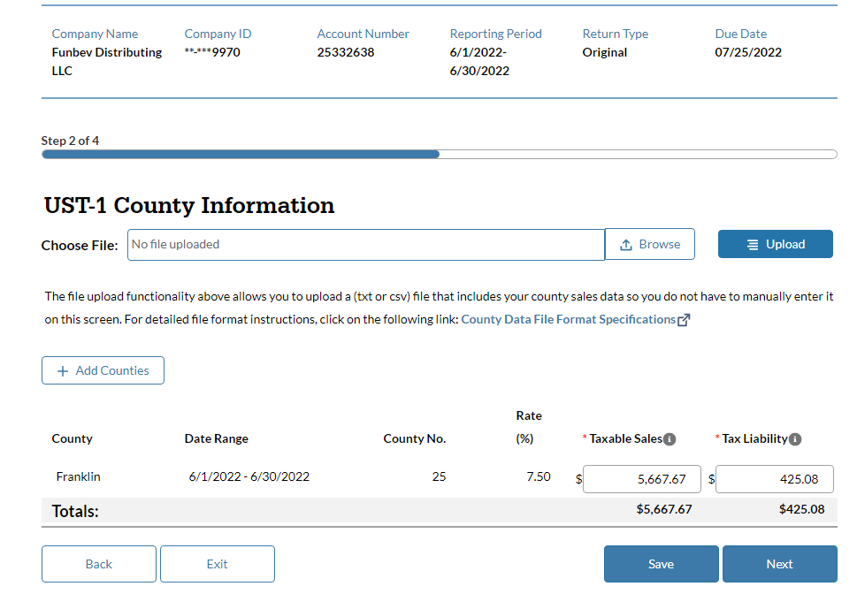

Select next and fill out the following prompts.

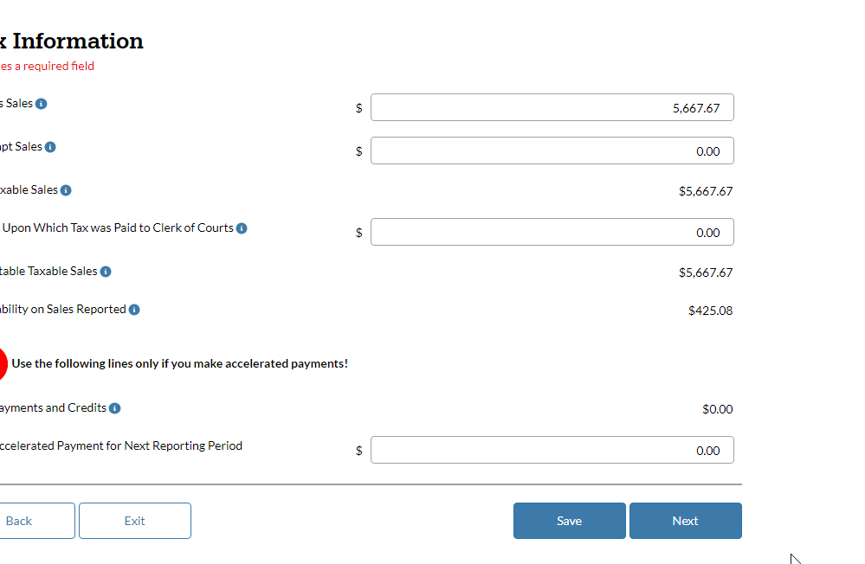
Select next and review the summary page. Once reviewed, acknowledge the tickbox and hit accept. Print the confirmation page, inform the client, and save to FileCabinet.

